# Capstone Project - Email Marketing Campaign

Step 1: Loading the csv file into a pig variable.

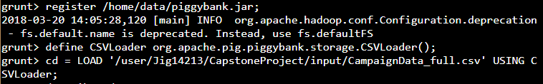

Step 2: Certain data transformations and pre-calculations need to be implemented.

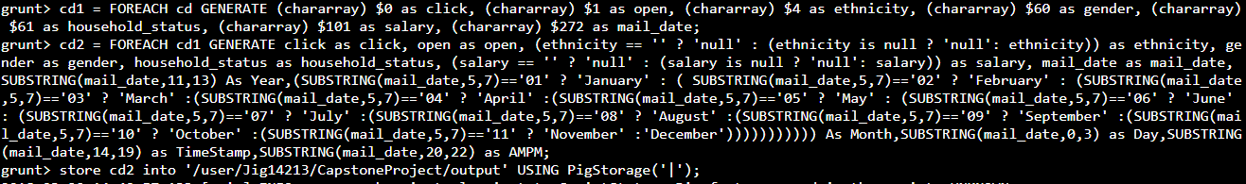

Step 3: Loading data in Hive variable – “cust_camp”. Total Rows - 1785422

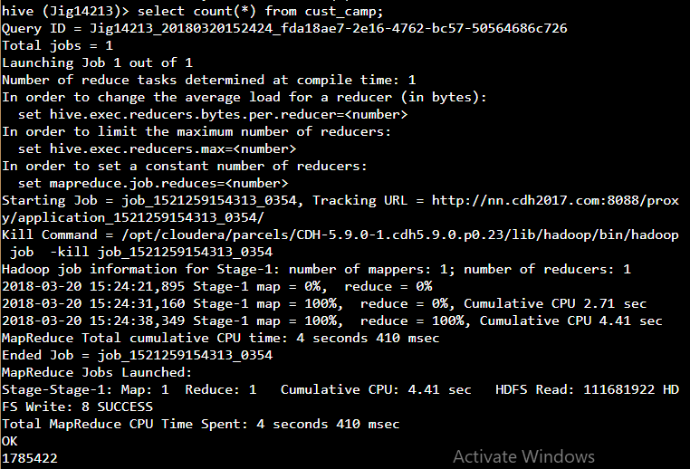

## Find the Click to Open Rate (CTOR)

A. Overall CTOR (use CLICK_FLG and OPEN_FLG column)

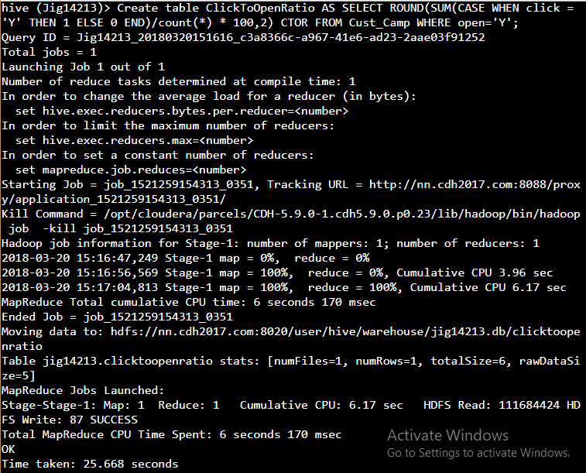

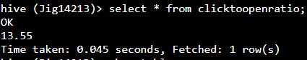

B. CTOR by Gender (use I1_GNDR_CODE column)

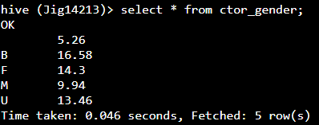

C. CTOR by Time of the day (use mailed_date column)

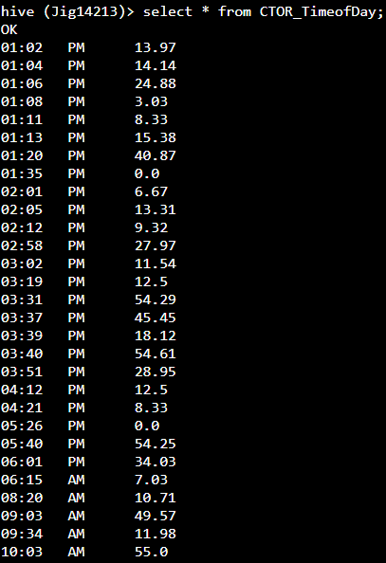

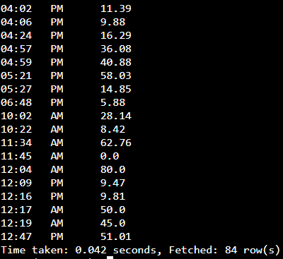

D. CTOR by Day of the week (use mailed_date column)

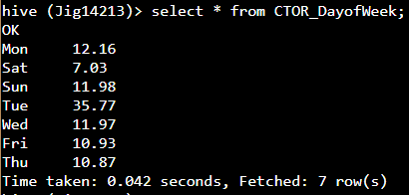

E. CTOR by Month (use mailed_date column)

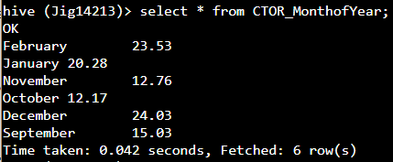

F. CTOR by Lead’s Income Group (use TRW_INCOME_CD_V4 column)

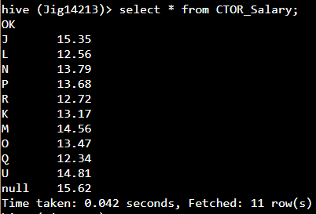

G. CTOR by Lead’s Ethnicity (use ASIAN_CD column)

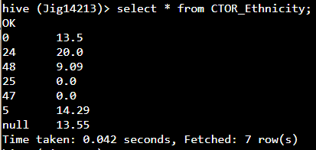

H. CTOR by Lead’s Household Status (use I1_INDIV_HHLD_STATUS_CODE column)

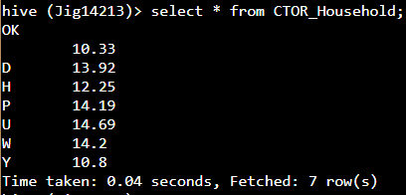

### Dashboard View1 of CTOR details:

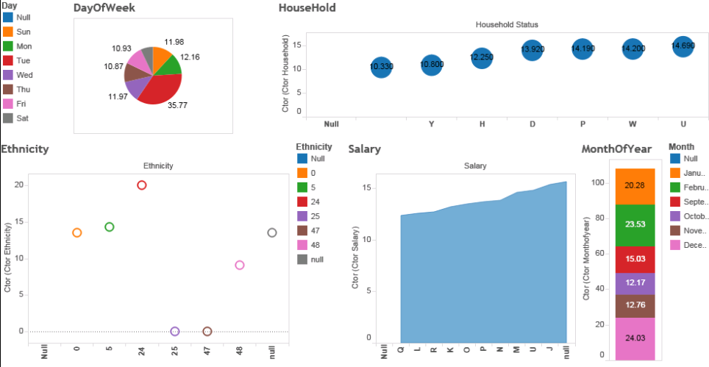

### Dashboard View2 of CTOR details:

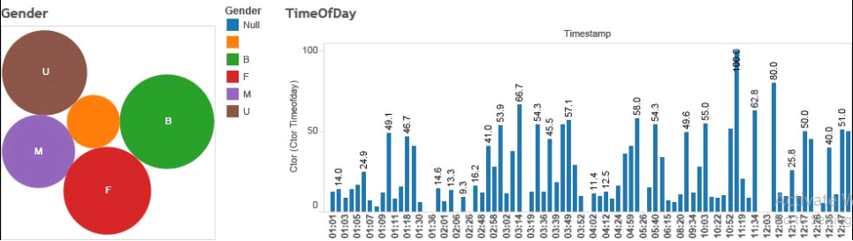

## Household Members Information

Step 1: Loading the csv file into a pig variable.

Step 2: Certain data transformations and pre-calculations need to be implemented.

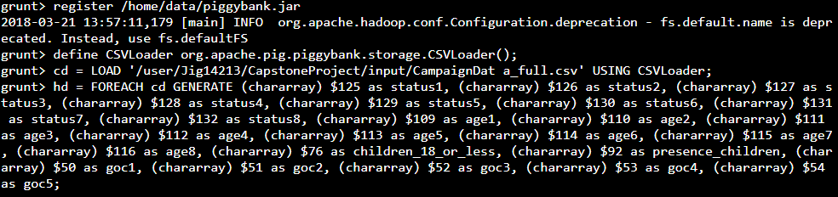

A. Find count of leads with information about members of their household. If a

lead has information about 3 members, and another has information about 2

members and another has none, then the answer to this question is 2.

(use statcd_hh_mem1 - statcd_hh_mem8 column)

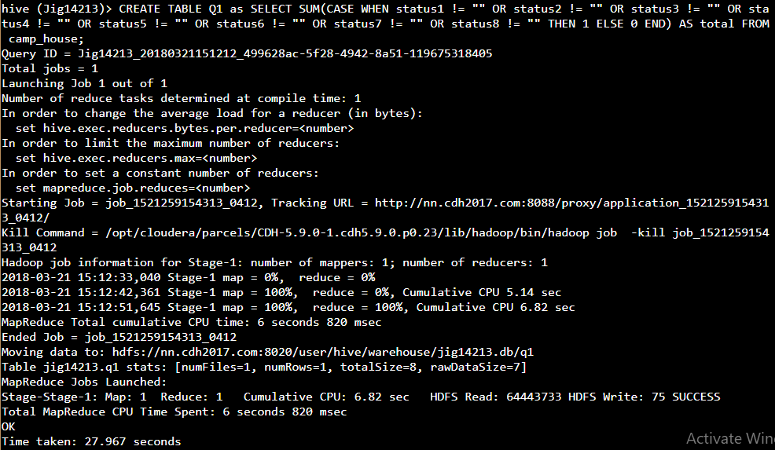

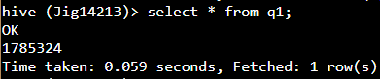

B. Find count of total number of household members information is available. For

example, if a lead has 3 household members, and another has about 2

members, and the other has none, then the total count of household members is

3+2+0 = 5.

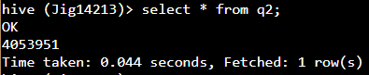

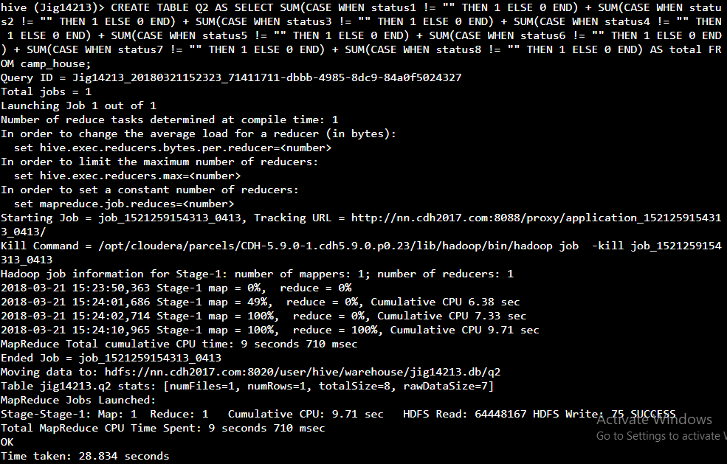

C. Find count of household members by type (Head of Household, Spouse etc.).

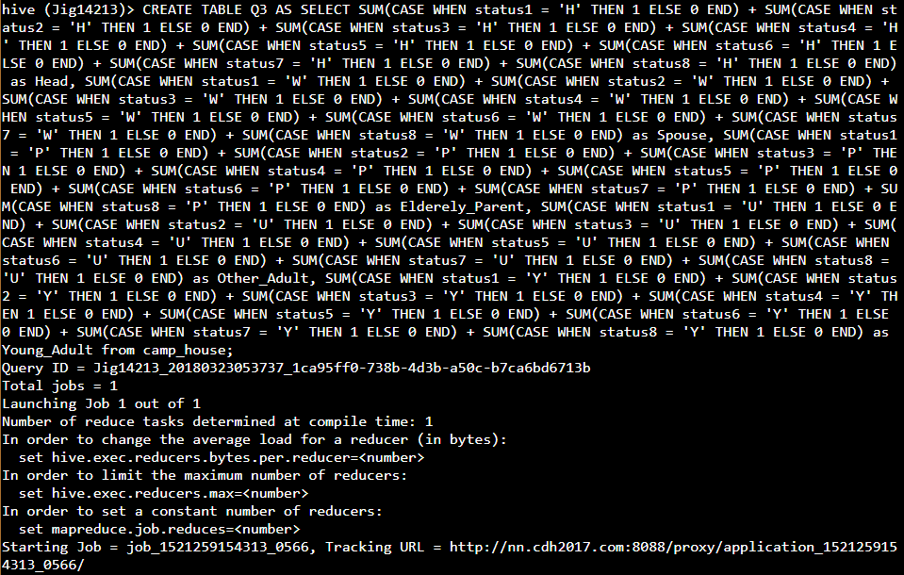

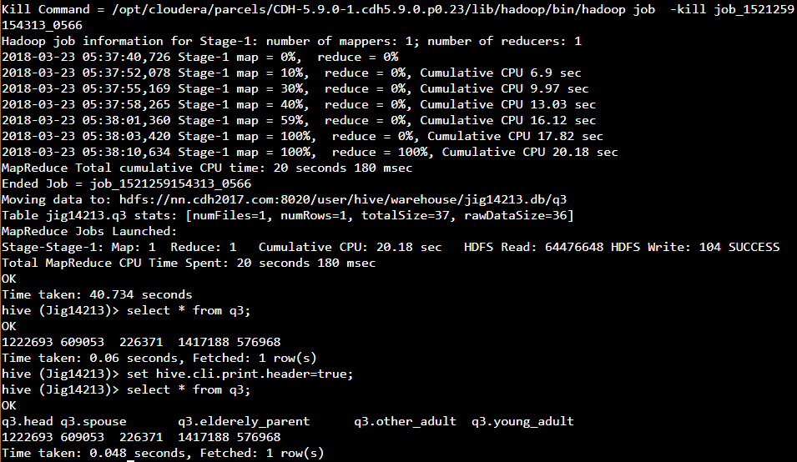

D. %age of household members type. For example, if there are 5 Head of

Household, 10 Spouse and 85 in the other categories, then the %age of

Spouses is 10.





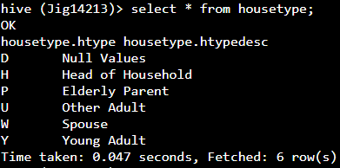



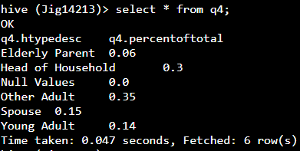

E. How many known households have children?

(use PRESENCE_OF_CHLDRN column)

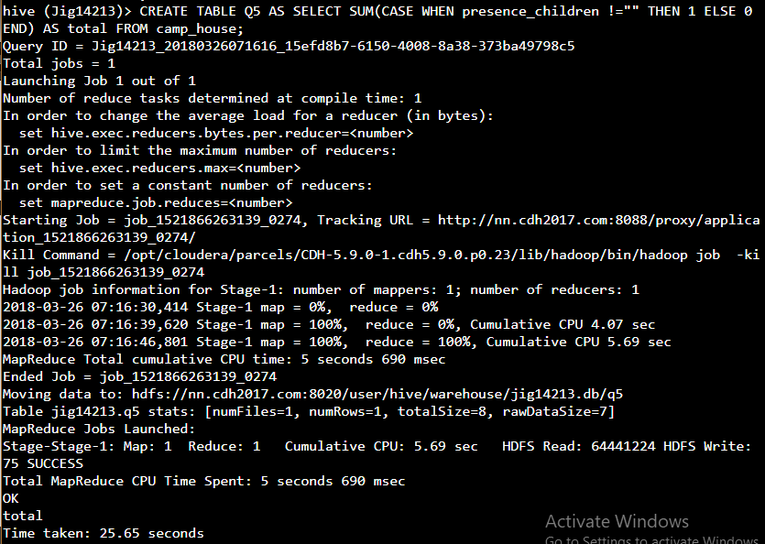

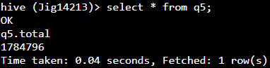

F. Overall, how many children are there?

(use NUMBER_OF_CHLDRN_18_OR_LESS column and PRESENCE_OF_CHLDRN ).

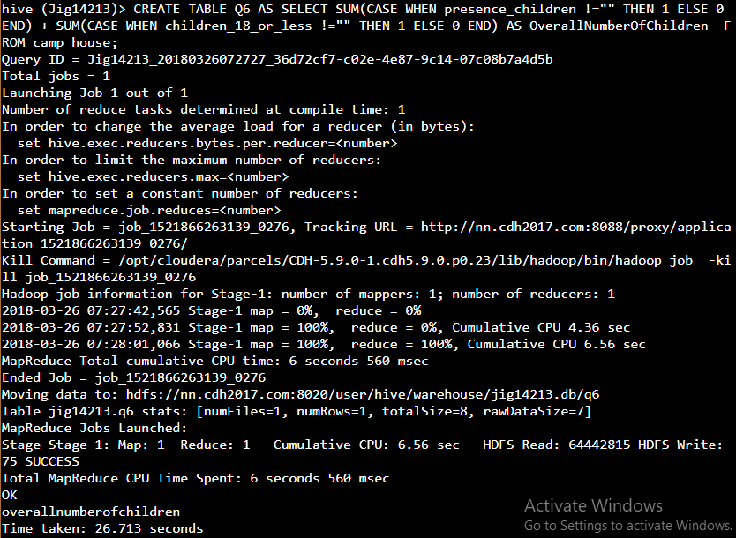

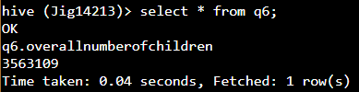

G. How many of the children are male and how many are female?

(use GNDR_OF_CHLDRN_0_3 - GNDR_OF_CHLDRN_13_18 column)

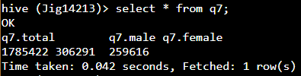

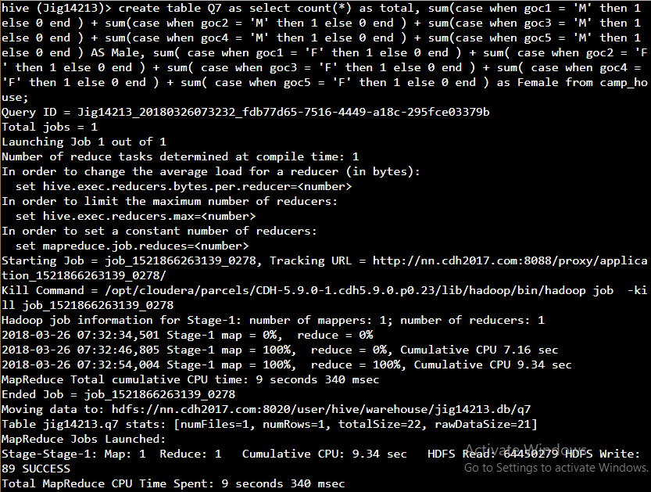

### Dashboard View1 of HOUSEHOLD details:

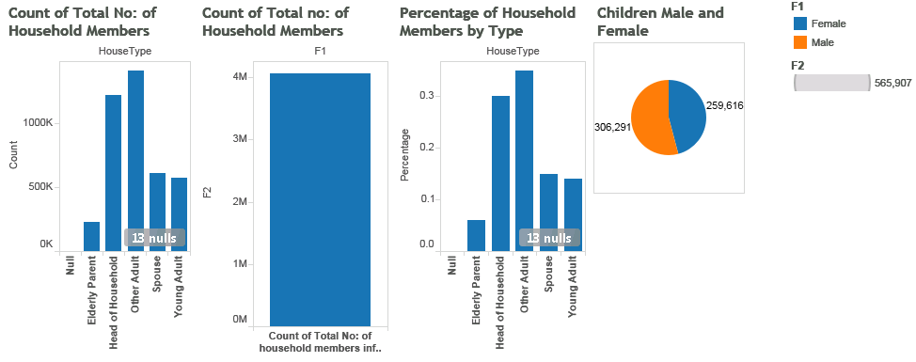

### Dashboard View2 of HOUSEHOLD details:

